**MACHINE LEARNING**

* Avocado Average Price Prediction
* Customer Churn Prediction

Date: 17 April 2021

Author: Pooja Mishra

Contents

Avocado Average Price Prediction 1

Introduction 1

Problem Definition 1

Data Analysis 1

Workflow 2

EDA (Exploratory Data Analysis) 2

Data Pre-processing 4

Building Machine Learning Models 5

Conclusion 8

Telecom Customer Churn Analysis 9

Introduction 9

Problem Definition 9

Data Analysis 9

Workflow 10

EDA (Exploratory Data Analysis) 10

Data Pre-processing 13

Building Machine Learning Models 16

Conclusion 19

# Avocado Average Price Prediction

# Introduction

Estimation of Avocado Average price prediction using Machine Learning Algoriths. With help of Machine Learning (ML) technology, we can predict price problems formulated as Regression analysis, in which a statistical technique used to estimate the relationship between a target variable i.e dependent variable and single or multiple independent variables.

This blog will focus on the ML algorithms performed on Avocado dataset to predict prices using different independent variables.

# Problem Definition

Avocado, is a dark green color botanically large berry containing a single large seed. It is originating from south-central Mexico. There is dozen variety of avocado, but more than 85% of Avocados harvested and sold in world are of Hass one. It heavily consumed by United States’ people.

In this blog, we’ll analyse the avocado price prediction. This data was downloaded from the Hass Avocado Board website in May of 2018 & compiled into a single CSV.

# Data Analysis

This dataset consists of several columns mentioned below:

* Date - The date of the observation
* AveragePrice - the average price of a single avocado
* type - conventional or organic
* year - the year
* Region - the city or region of the observation
* Total Volume - Total number of avocados sold
* 4046 - Total number of avocados with PLU 4046 sold
* 4225 - Total number of avocados with PLU 4225 sold
* 4770 - Total number of avocados with PLU 4770 sold

The variables of the dataset are present in different types of data types as explained in the following:

* Categorical: ‘region’,’type’
* Date: ‘Date’
* Numerical: ‘Unamed: 0’,’Total Volume’, ‘4046’, ‘4225’, ‘4770’, ‘Total Bags’, ‘Small Bags’,’Large Bags’,’XLarge Bags’,’Year’
* Target: ‘AveragePrice’

The aim is to predict the average price of Avocados which is continuous in nature and using the all independent features present in the dataset. For that purpose, let’s confirm the type of problem, so it is regression type problem on which we’ll be performing several types of regression algorithms to predict avocado price.

# Workflow

To predict the average price of Avocados we’ll be performing following workflow to regularise the dataset followed with all regression algorithms that will help in predicting the prices.

Label Encoding

Data Cleaning

EDA

Identify the Problem

Importing Dataset

Hyper Parameter Tuning

Performing Algorithms

Find best Random State

Splitting in x & y

Saving the Best Model

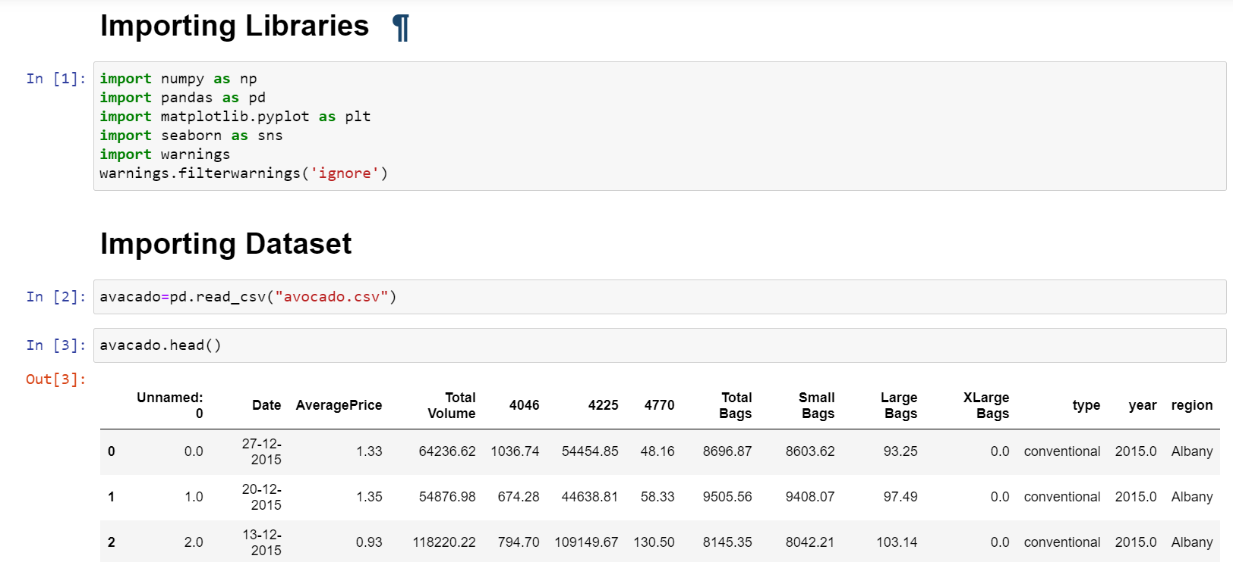

In above image we have imported the initial libraries and algorithms libraries are imported later in this programming then imported the dataset so that we can perform further techniques to make the dataset ready prior implementing all algorithms.

# EDA (Exploratory Data Analysis)

Data Preparation:

To visualise the dataset of avocado we’ll perform initial steps to make data standard. We’ll be applying below mentioned activities to make the dataset ready for visualization.

1. Identifying the data types of all columns.
2. Checking total number of rows and columns.
3. Dropping the columns which will not participate in prediction of average price.
4. Checking the null values. Plotting its heatmap.
5. Replacing null values with mean or mode.
6. View the statistical summary of dataset.

After performing all above steps on dataset, we have observed following information about the dataset as well as rows and columns present.

Observations:

1. About the datatypes, we have observed that there are 3 are object type and 10 are float type.
2. Total number of rows present are 16468 entries along with 13 columns.
3. We observed that column ‘Unnamed’, ‘Date’ are not much participating in prediction of price thus dropped it. ‘Region’
4. Filling the null values in columns –

Date 14951

AveragePrice 14951

Total Volume 14951

4046 14951

4225 14951

4770 14951

Total Bags 14951

Small Bags 14951

Large Bags 14951

XLarge Bags 14951

type 14951

year 14951

region 14951

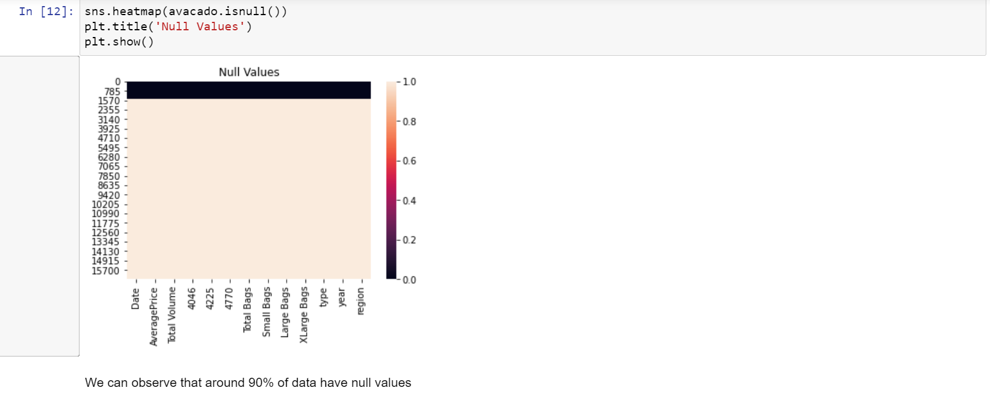

From above heatmap we can observe that, around 90% of values are null because the white colour is equally distributed correspond to each other. Almost all the columns have null values present.

Removing Null Values:

Removing of null values is very important to operate algorithms on the dataset to get the predictions. The most common imputations are using of mean, medium, or mode to fill the values of each column. For categorical data, mode value will replace all null values, for non-categorical values use mean, median to fill the null values.

Similarly, in this dataset we have used the mode to fill all rows that have null values and mean for filling non-categorical rows that have null values.

1. After applying mode and mean technique, all null values have been removed without any loss of data.
2. By applying statistical technique, we observed that the mean, 50% of data values and std are same or very close to each other. For few variations in 75% data values and max values, there can be outliers. Outliers present in columns need to treat later to make dataset ready for algorithm performance.

Data Visualization:

In this section we can plot different graph using different columns and try to visualize the data using matplotlib and seaborn library. We used different graphs to visualise the relationship of all features with target variable ‘AveragePrice’. We are univariant and bivariant analysis using barplot.

The histogram analysis performed on all variables showing the relationships with all variables. By histogram analysis we can observe the skewness in the dataset.

Barplot analysis done between ‘year’ and ‘AveragePrice’ showing year 2016 has maximum avocado average price.

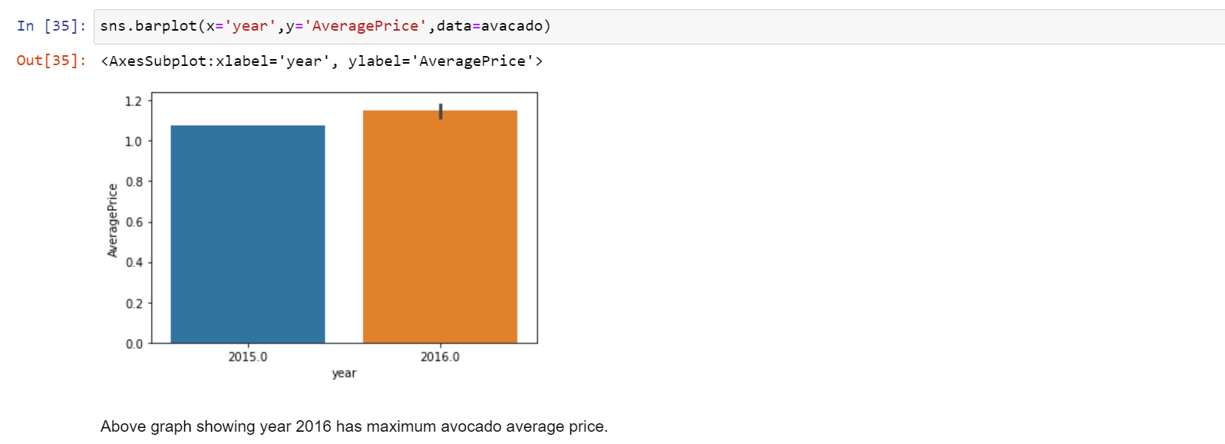

# Data Pre-processing

Data pre-processing is very important to get the dataset into the best format before performing algorithm. This is very important step in Machine Learning that should not be skipped. It involves three stages: Data Cleaning, Data Transformation, and Feature Engineering which converts complicated dataset into quality data.

Data Cleaning:

In Data cleaning, we understand the data, we perform several activities to clean the data. This stage comprises of following activities:

1. Dealing with Null Values – In this dataset, we have found more than 90% values are null so filled it with mean and mode as per the category of values as presented in above workflow step.
2. Dealing with Skewness – In this dataset, few of the columns do not follow the normal distribution that need to treat to convert it into normal distribution. In this step, we checked the skewness and used the NumPy log method to make the skew values into normally distributed.

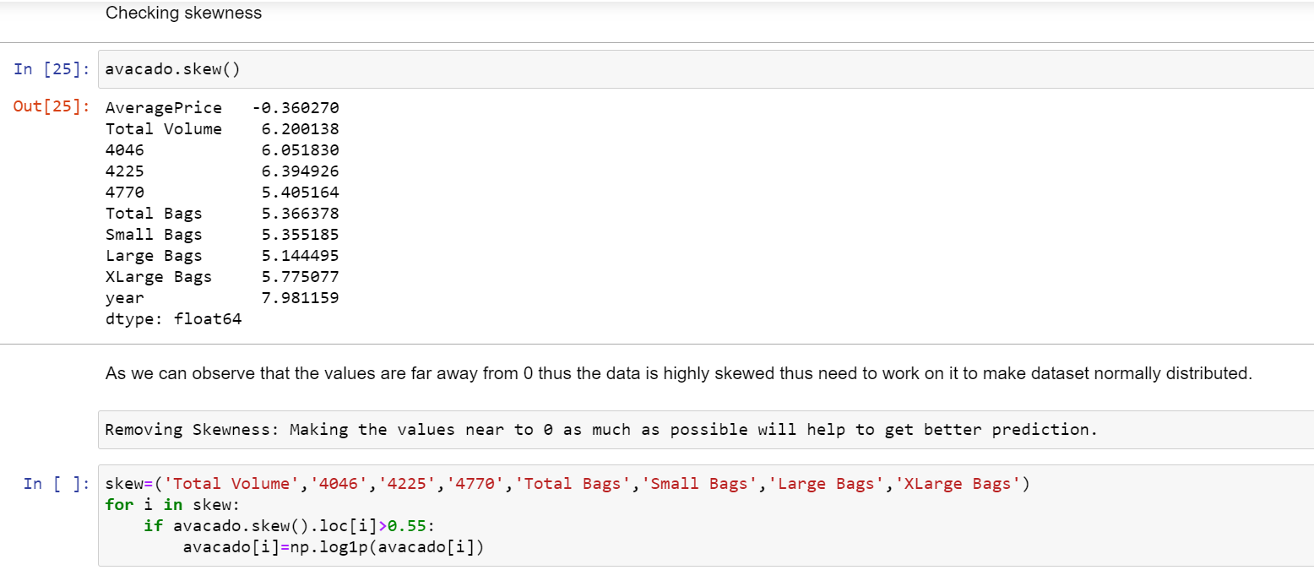

In above image, you can see the columns which have skewed values, i.e. not normally distributed thus making the values near to 0 using NumPy log.

Outliers:

An **outlier** is a data point in a dataset that is distant from all other observations i.e. a data point that lies outside the overall distribution of the data set. Depending on the frequency of outliers, we’ll perform activities to remove it.

In this Avocado dataset, first we checked the outliers. We found outliers present in the dataset and performed zscore to remove it.

Data Transformation:

In Data transformation we recheck that all present columns are numerical or not? if not then we perform encoding type depending on the type of values present in columns.

Here in this dataset, we performed Label Encoding to convert categorical values in numerical.

Most important thing we need to keep in mind that all data pre-processing steps will be performed according the dataset present.

Correlation Matrix:

**Correlation** Matrix is a covariance matrix. A summary measure called the **correlation** describes the strength of the linear association.

In this dataset, we have described the correlation and relationship present amongst each feature with target variable. Here we observed that Total volume, Small Bags, Total Bags, 4225 showing highly positive correlation. With help of heatmap graph we can observe same the positive and negative correlation.

# Building Machine Learning Models

As our data are ready now! Let's now begin to train out regression model! We will need to first split up our data into an x array that contains the features to train on, and a y array with the target variable.

Prediction on Target variable i.e. ‘Average Price’

Here we are making two variable x and y where x is having all column except Average Price and Date, and y is having only Average Price column as shown in below image.

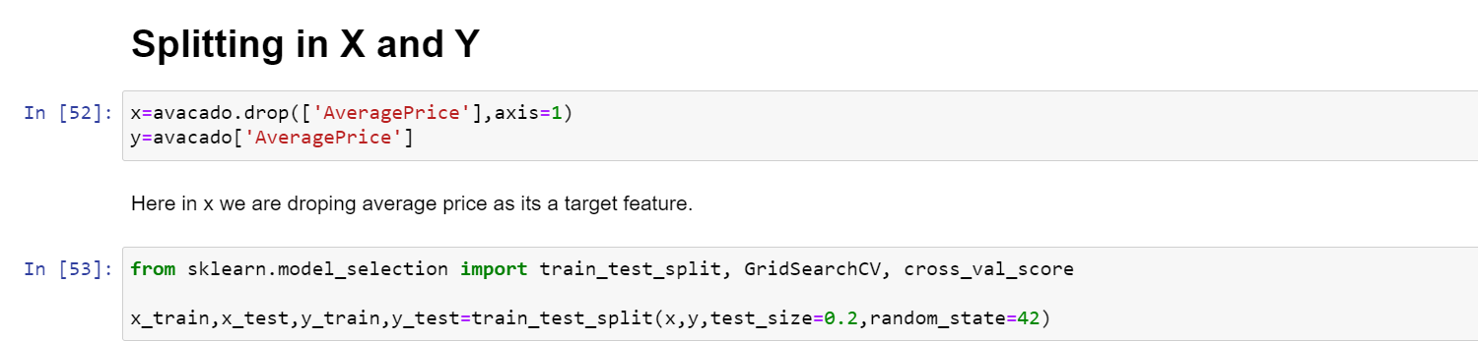

Creating and Training the model:

We had done this prediction by taking Average price as an output variable which is continuity in nature so that why using the regression techniques.

Now using multiple regression algorithms to find the best fit model for predicting the average price.

In this dataset, we have performed all regression type algorithms as mentioned below –

i)DecisionTreeRegressor

Using Decision Tree Regressor, we are getting accuracy of 68%

ii)KNeighborsRegressor

Using Kneighbors Regressor, we are getting accuracy of 73%

iii)AdaBoostRegressor

Using Ada Boost Regressor, we are getting accuracy of -117%

iv)LinearRegression

Using Linear Regression, we are getting accuracy of 30%

v)GradientBoostingRegressor()

Using Gradient Boosting Regressor we are getting accuracy of 65%

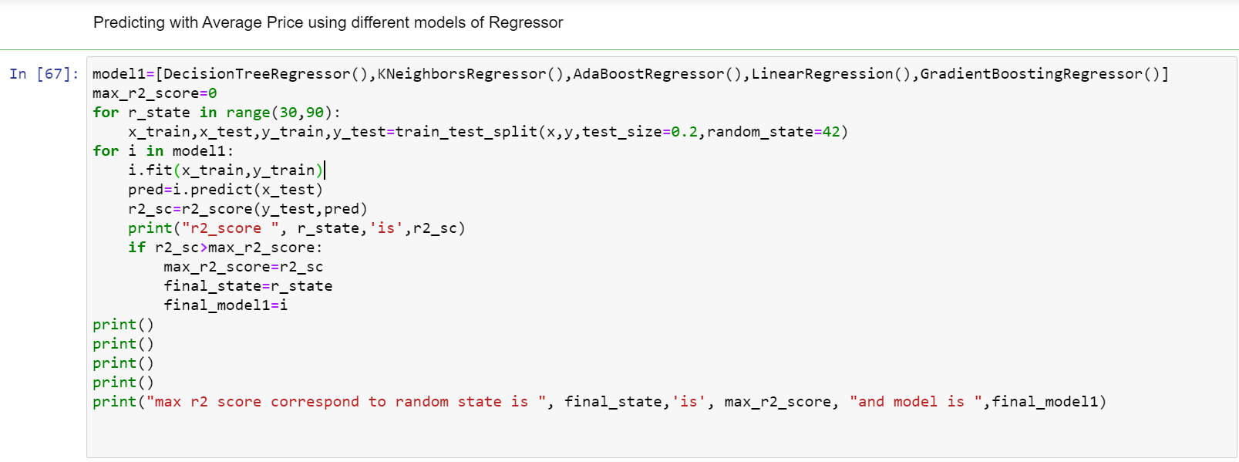

Thus, in this dataset we are getting highest score of 73% for model Kneighbors Regressor.

Hyper Parameter Tuning:

* After identifying the best model as Kneighbors Regressor, we used the GridSeachCV, so we can find the best param and then we used these param for that model.

**Let’s see final Actual Vs Predicted sample.**

To confirm that we have chosen best model, lets plot normal distribution to confirm the model.

Here you can see the normally distributed model:

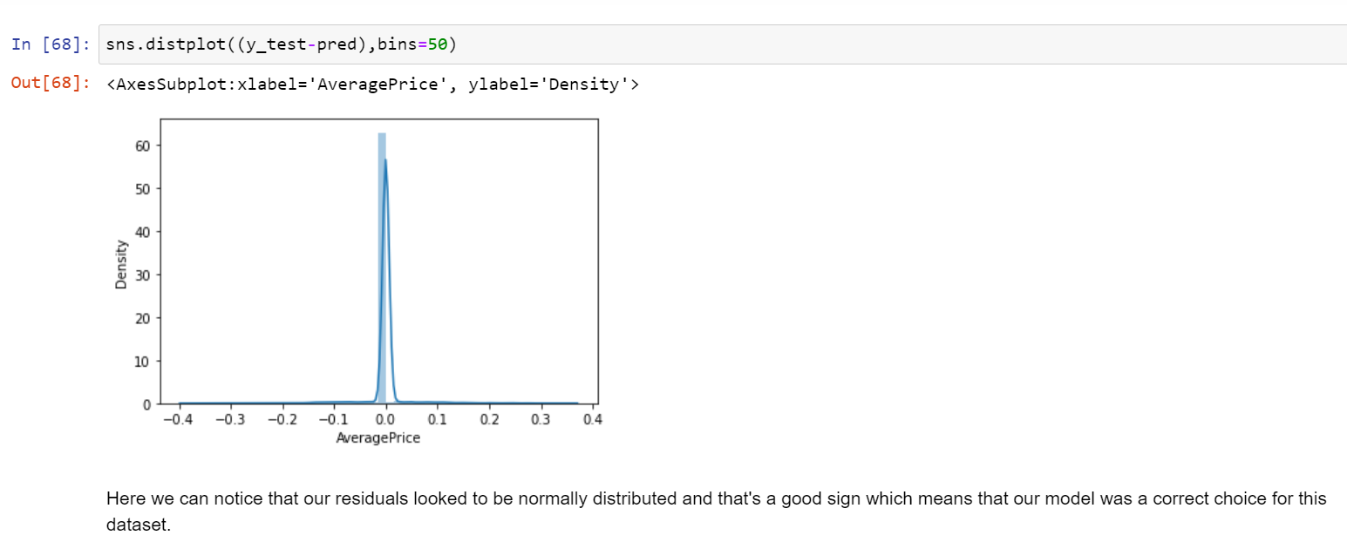

Now checking the difference between actual and predicted value, we plotted the scatter graph which shows positive correlation in actual and predicted values thus this model proves to be a best fit mode for this dataset.

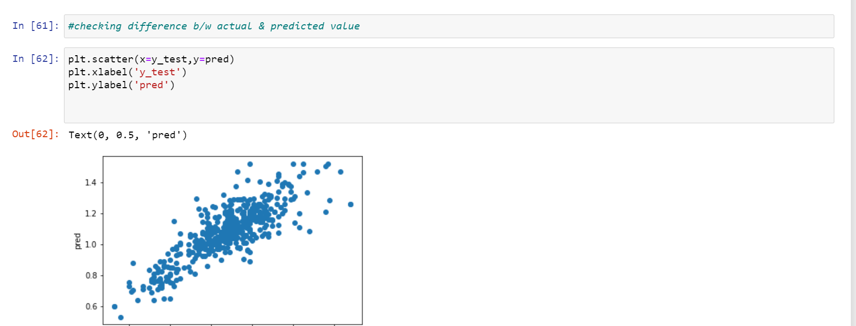

Using pickle, we can save the best model KNN and can be useful to calculate the accuracy score and predict outcomes on new data.

# Conclusion

Thus, we can conclude that by performing all regression models, we came to know about the best model that predict the average price of Avocados. The Kneighbors Regressor model with 73% amongst all models proves that it’s the best model to go on. The normal distribution and positive correlation in graphs of actual and predicted value confirms the model is best fit.

Check out the ‘Avocado Average Price Prediction’ entire code on my Github profile:

<https://github.com/github-pooja/Data-Trained-Practice-Projects/blob/main/Avocado%20Price%20Prediction%20%20(1).ipynb>

Thank You.

# Telecom Customer Churn Analysis

# Introduction

Customer churn analysis basically is a method to predict the customer retention rate by performing machine learning techniques. As we all aware that customer attrition is a big issue in any industry. One of the major focus of a data scientist is to reduce customer attrition and increase customer retention.

In the telecom industry, customers can choose from multiple service providers and actively switch from one operator to another. Thus, customer retention has now become more important than customer acquisition to reduce customer churn, telecom companies need to predict which customers are at high risk of churn with help of Machine Learning.

# Problem Definition

In this project, we will analyse customer-level data of a leading telecom firm, build predictive models to identify customers at high risk of churn and identify the main indicators of churn. From this dataset, our focus is to try and build a simple algorithm model to predict whether a customer will churn or not in given dataset.

# Data Analysis

In this, all data is related to the customer’s telephonic data. Here we have 21 columns and 7043 rows. Amongst 21 columns we have target variable as well which is known as ‘churn’.

* Data is present in a file: <https://github.com/dsrscientist/DSData/blob/master/Telecom_customer_churn.csv>

This dataset consists of following columns as listed below:

customerID

gender

SeniorCitizen

Partner

Dependents

tenure

PhoneService

MultipleLines

InternetService

OnlineSecurity

OnlineBackup

DeviceProtection

TechSupport

StreamingTV

StreamingMovies

Contract

PaperlessBilling

PaymentMethod

MonthlyCharges

TotalCharges

Churn

There are 18 object type, 2 integer type and 1 float type variables present in this dataset. As well as we also observed that there are only 3 numeric columns and rest 18 are non-numeric columns.

We will try and identify the variables which are significant in predicting customer churn and it’s a classification problem so try to build a logistic regression model which will accurately predict the

churn.

# Workflow

To predict the customer churn from this dataset, we’ll be performing following workflow to balance the dataset by following all data pre-processing techniques followed with all classification algorithms that will help in predicting the churn.

Identify the Problem

EDA

Data Pre-processing

Importing Dataset

Hyper Parameter Tuning

Performing Algorithms

Find best Random State

Splitting in x & y

Saving the Best Model

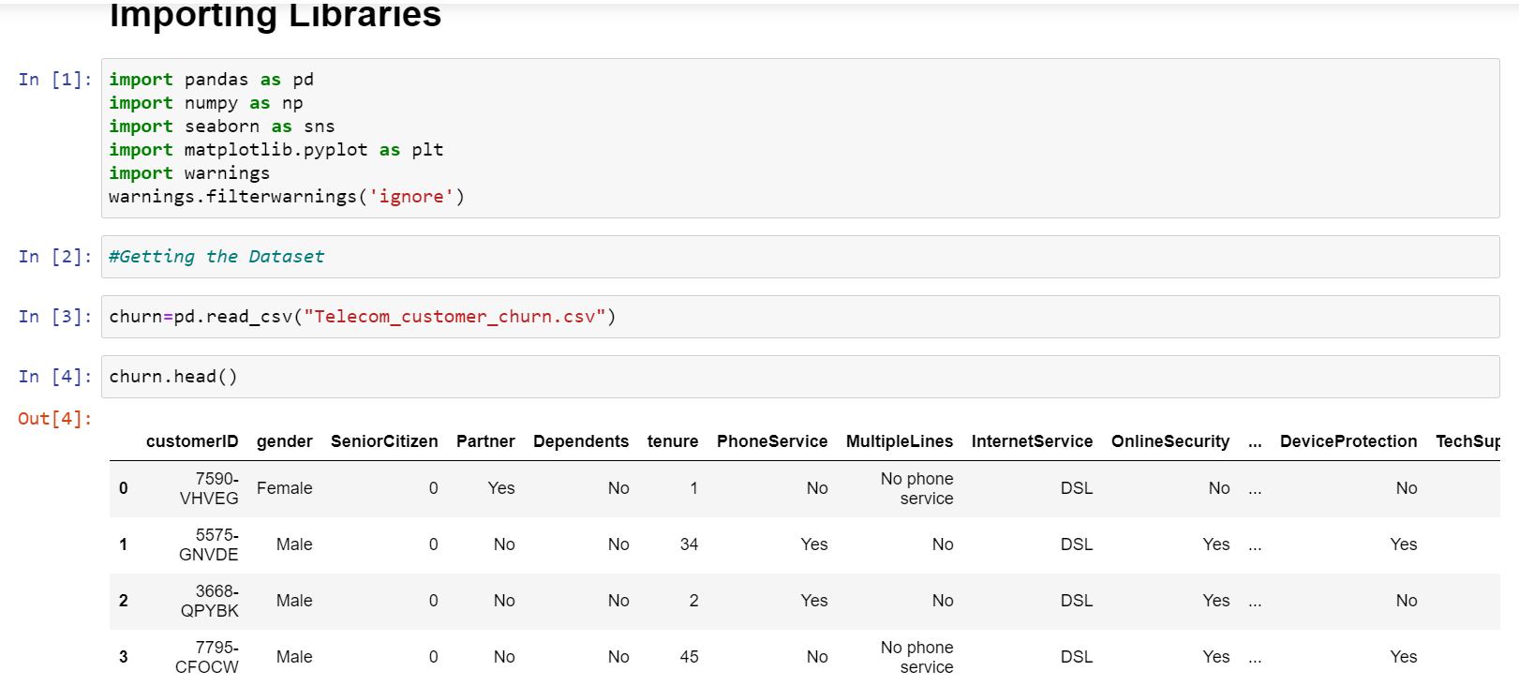

# EDA (Exploratory Data Analysis)

In this project, we are dealing with a high dimensional dataset. Hence data analysis and data pre-processing are very crucial to make the dataset standard.

Data Preparation:

We’ll be applying below mentioned activities to make the dataset ready for visualization.

1. Identifying the data types of all columns.
2. Checking total number of rows and columns.
3. Checking the null values.
4. View the statistical summary of dataset.

After performing all above steps on dataset, we have observed following information about the dataset as well as rows and columns present.

Observations:

1. As mentioned above as well, the datatypes of all 21 columns are mixed in which only 3 column values are numeric rest 18 columns have non-numeric values on which we’ll be working later to dataset standard.
2. There are total 21 columns and 7043 rows entries.
3. After checking the null values, we found that there are no null values present thus no such techniques will be performed for null values removal.
4. From statistical summary, we can observe the range in values, mean, median and mode of all columns.

Data Visualization:

In this section we can plot different graph using different columns and try to visualize the data using matplotlib and seaborn library. We used different graphs to visualise the relationship of all features with target variable ‘Churn’. We are univariant and bivariant analysis using barplot and countplot.

By distribution graph we can observe that the data is normally distributed or not; based on which we’ll be performing activities to make the data normal.

Here are few graphs showing the relationship with all features:

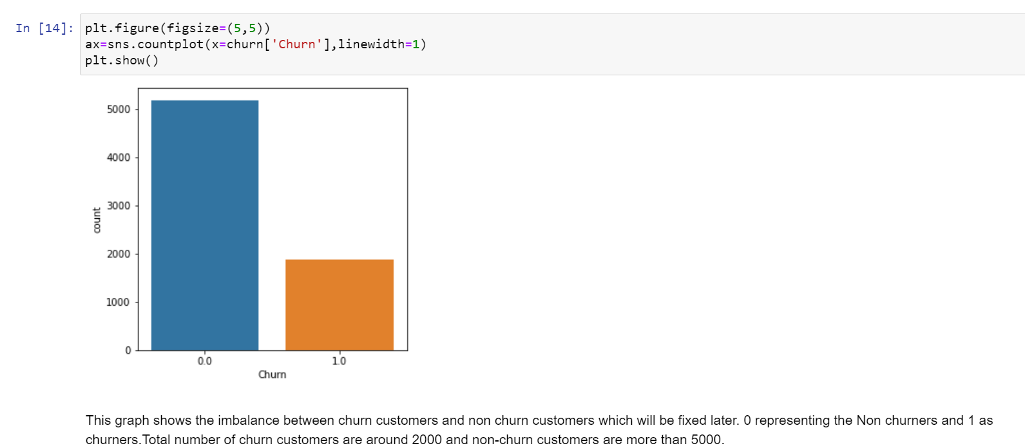

Above graph showing churn counts.

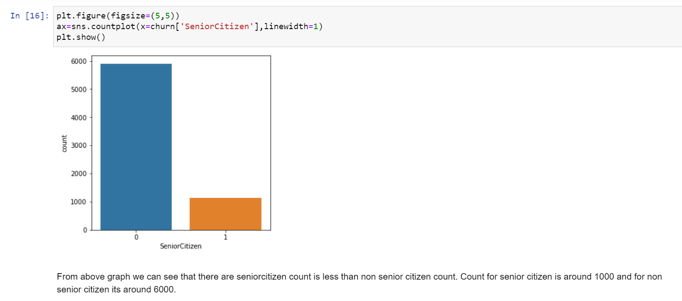

Above graph showing relationship between churn and senior citizens.

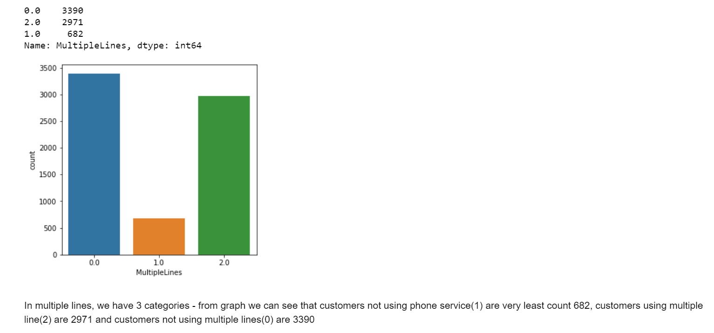

Above graph showing count of multiple lines users.

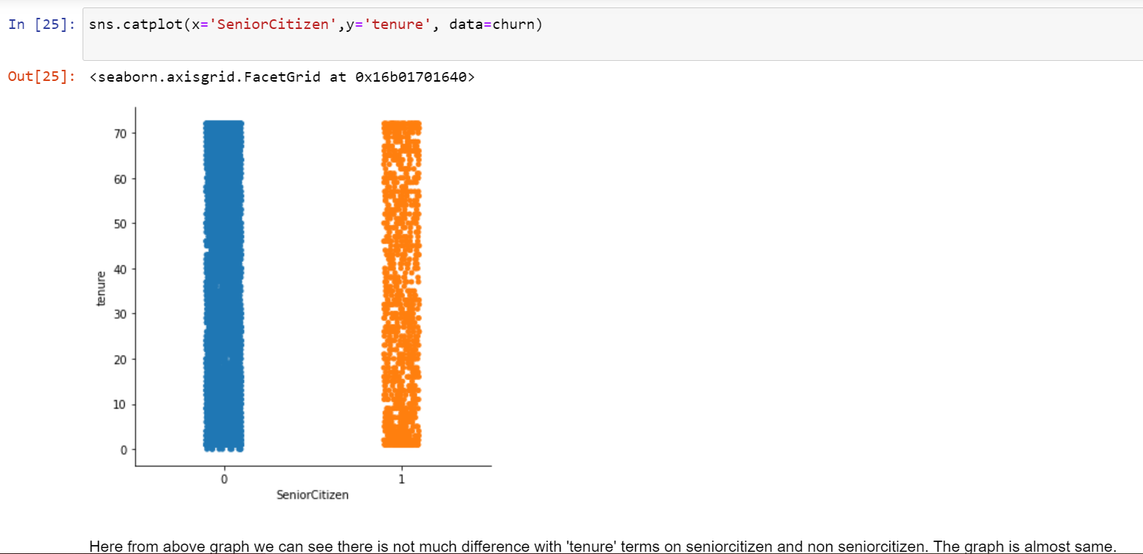

Cat plot showing relationship between tenure and senior citizen.

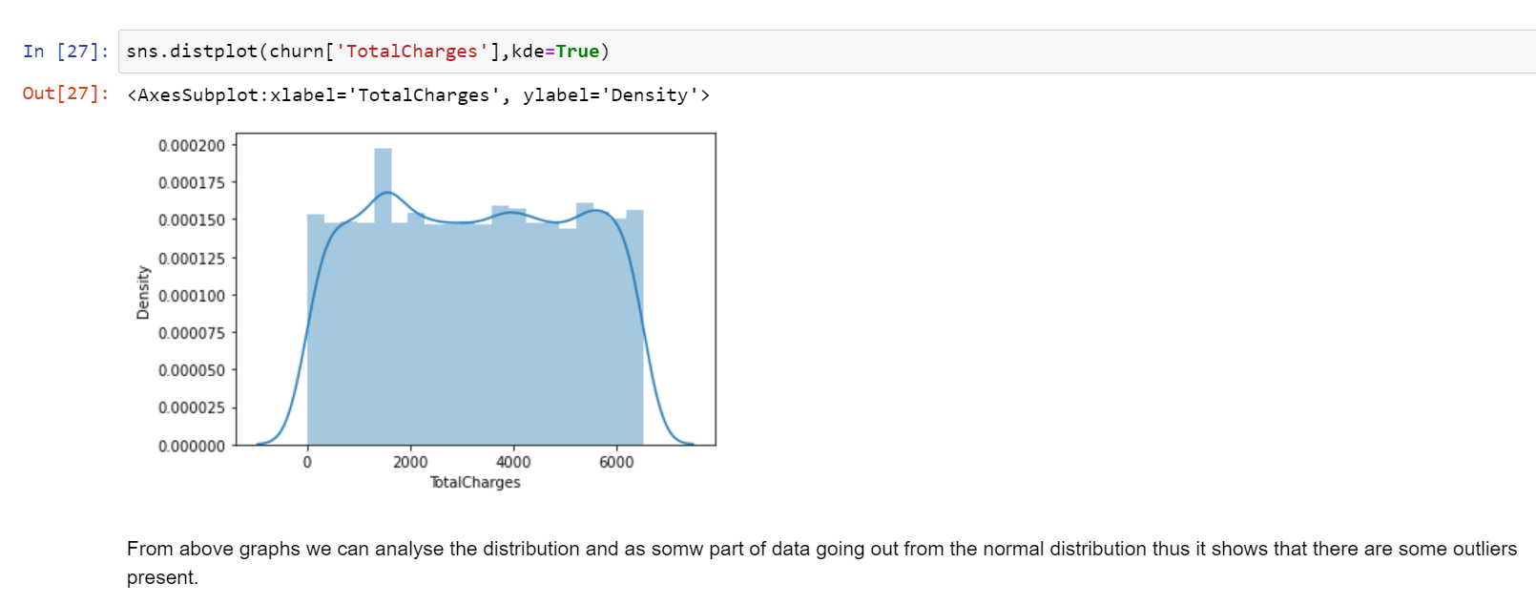

Above graph showing the distribution of totalcharges; this shows that there are very few outliers present in the dataset.

For EDA, we can also group the categorical columns and plot count graphs, as well as grouping the numerical columns to visualize the features with target variable.

# Data Pre-processing

Data pre-processing is very important to get the dataset into the best format before performing algorithm. This is very important step in Machine Learning that should not be skipped. It involves three stages: Data Cleaning, Data Transformation, and Feature Engineering which converts complicated dataset into quality data.

Data Cleaning:

In Data cleaning, we understand the data, we perform several activities to clean the data. This stage comprises of following activities:

Dealing with Null Values – As there are no null values present in this dataset, so no activities will be done to remove it.

Checking skewness – Next step is to check the skewness present in the dataset.

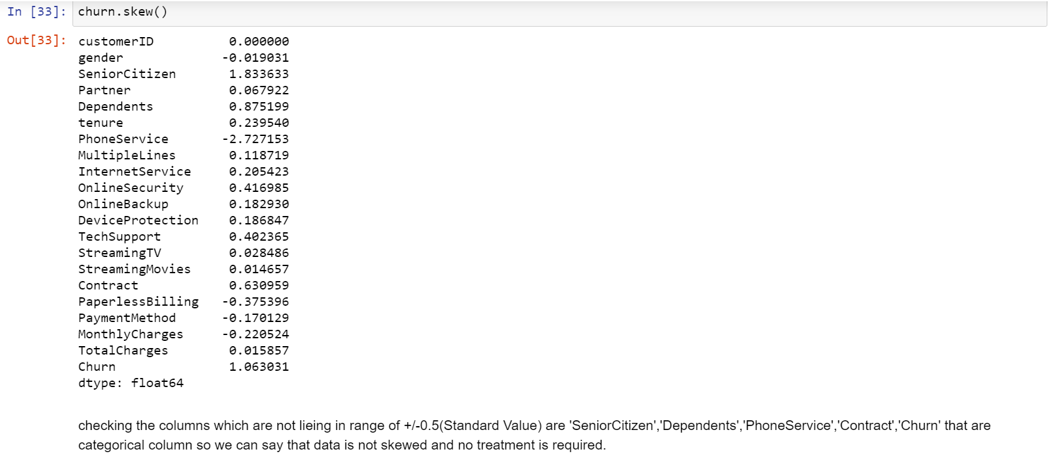

In this dataset, we observed that skewness is present in categorical columns. So no skewness removal activities will process because little skewness is present in categorical columns which can be ignored.

Checking Outliers: Outliers are data points that are present outside the distribution, thus its very important to remove it. Here in this dataset we found outliers by plotting boxplot graphs as shown in below fig.

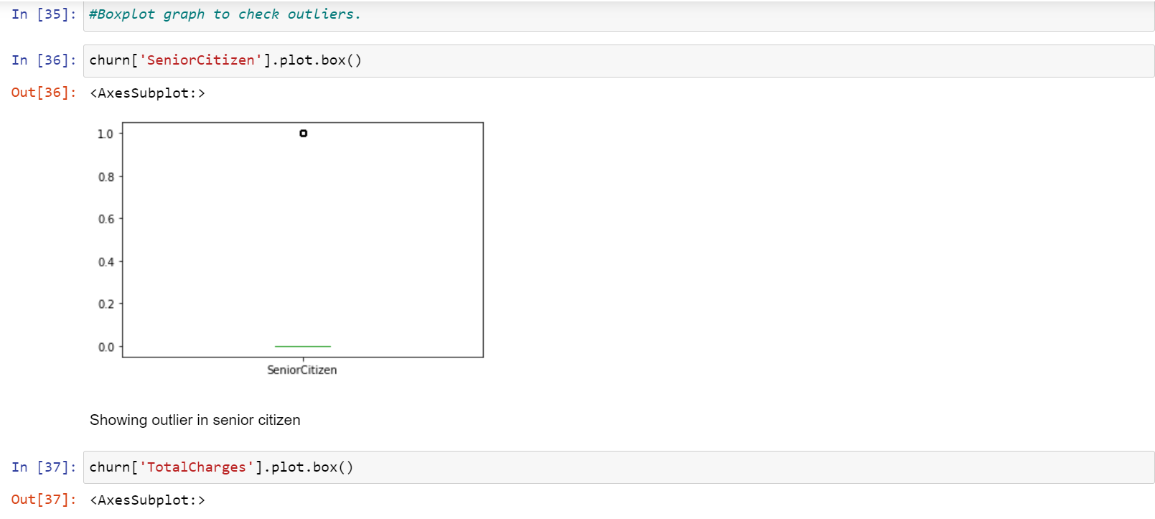

In this dataset, we found outlier in seniorcitizen column only. As it is nominal type thus, we’ll not consider it.

Data Transformation: In Data transformation, we check whether the columns are present in numeric or not? If not, then we need to perform Label Encoding or One-hot encoding to convert the object type into numeric.

Here in this dataset, we’ll be performing Ordinal encoding as most of columns have more than 2 values. In below mentioned fig. we can see that all columns containing object type values have been converted to numeric.

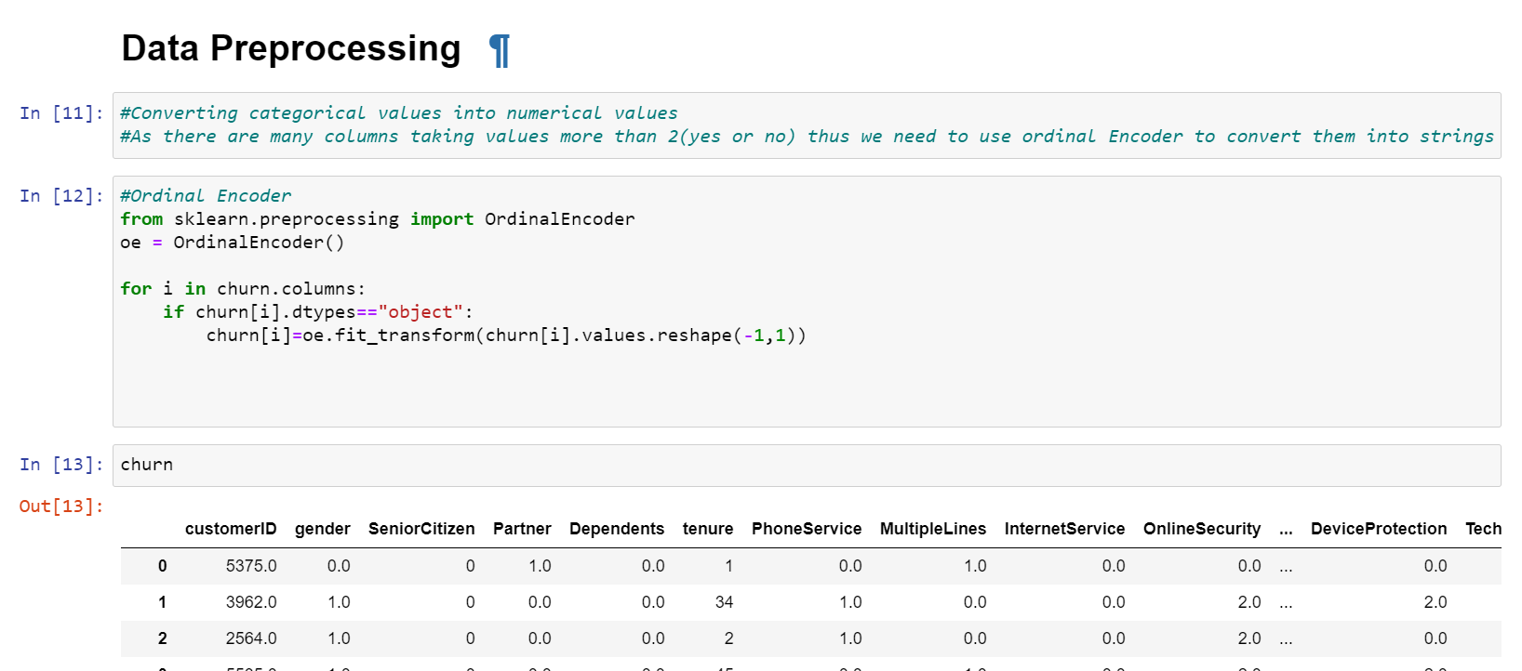

Feature Engineering:

In feature Engineering, is the process of creating new features based upon knowledge about current features and the required task. It involves 2 activities:

-Feature Extraction

-Capturing Feature Relationships

We check which columns are useful in prediction and which are not. The columns which are not contributing in analysis we can drop it.

Here in this dataset we can observed that customerID is not playing any vital role in the prediction thus we can drop it.

Correlation Analysis:

Correlation analysis shows the correlation of target feature i.e. churn with all remaining features.

The columns which are taken in consideration to perform modelling are as follows:

['gender', 'SeniorCitizen', 'Partner', 'Dependents', 'tenure',

'PhoneService', 'MultipleLines', 'InternetService', 'OnlineSecurity',

'OnlineBackup', 'DeviceProtection', 'TechSupport', 'StreamingTV',

'StreamingMovies', 'Contract', 'PaperlessBilling', 'PaymentMethod',

'MonthlyCharges', 'TotalCharges', 'Churn'],

Here from this dataset, we can see columns are very less positive and highly negative correlated with 'Churn' feature as shown in below fig.

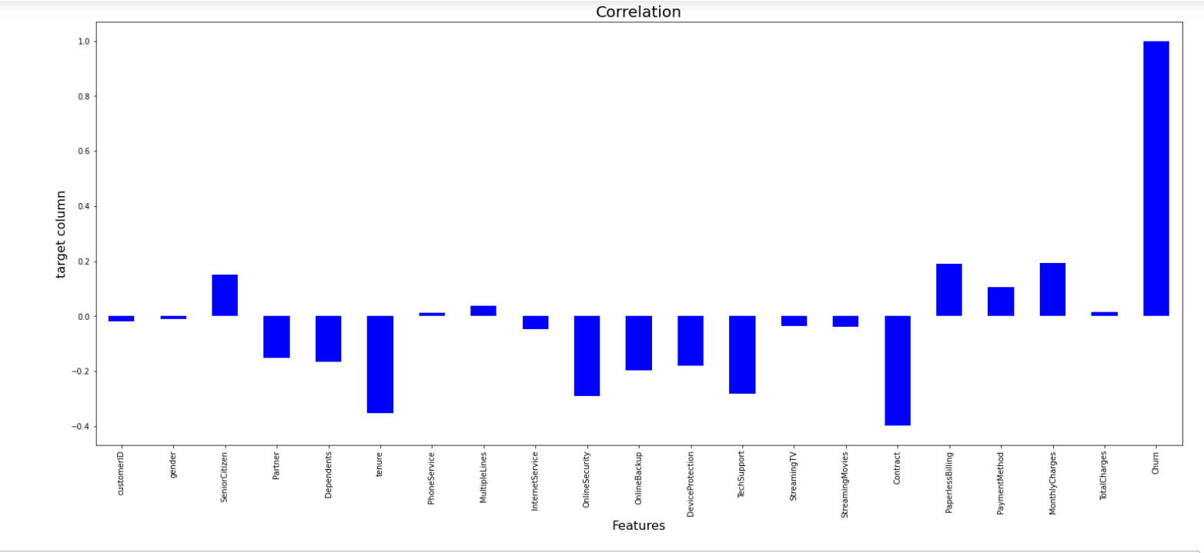

Feature Rescaling:

Min-max scaler is the standard approach for scaling. For normally distributed features standard scaler could be used, which scales values around a mean of 0 and a standard deviation of 1.

Here in this dataset we found values of numerical columns are not standard so for simplicity we use min-max scaler for all numerical features. Resulting we get our dataset ready with standardised data to perform all algorithms.

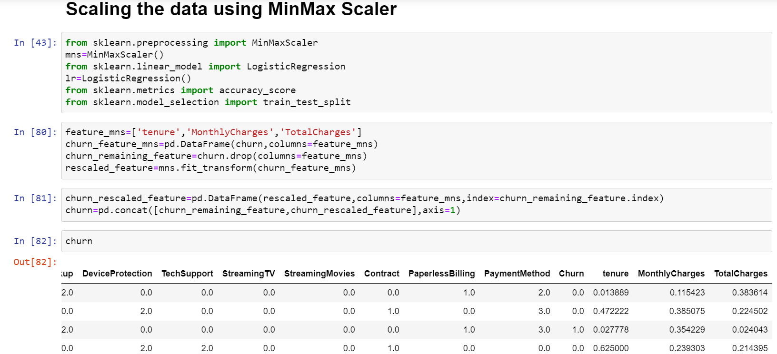

# Building Machine Learning Models

* Train Test Split

To conduction of model training and testing steps, we now split the data set into 80% training data and 20% test data. The “Churn” column is defined as the class (the “y”), the remaining columns as the features (the “x”). We have imported all related libraries for test train split.

* Model Building

To perform various model building we have called various metrics and libraries which we’ll be using for prediction of churn.

We had done this prediction by taking ‘Churn’ as an output variable which is classification in nature so that why using the classifier techniques.

Now using multiple classifier algorithms to find the best fit model for predicting customer churn.

Loading all classifier libraries and performed all below mentioned algorithms –

1. **Logistic Regression**

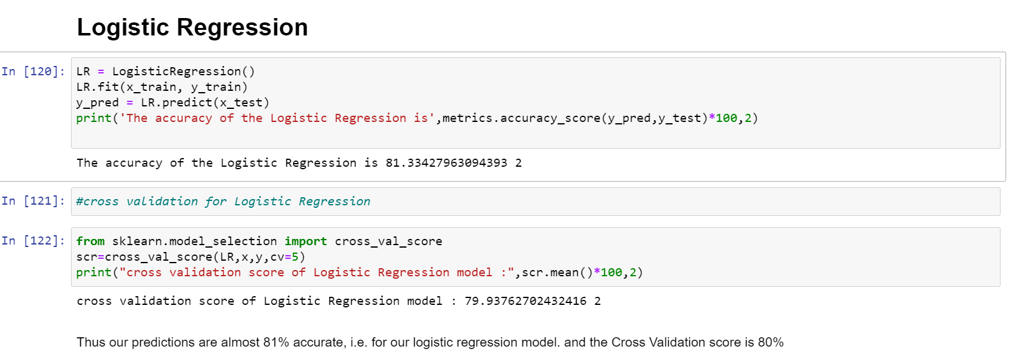

Using Logistic Regression, we are getting accuracy of 81% and cross validation its 80%.

We perform cross validation to re-check the accuracy as high accuracy can be because of over-fitting of data.

1. **Random Forest Classifier**

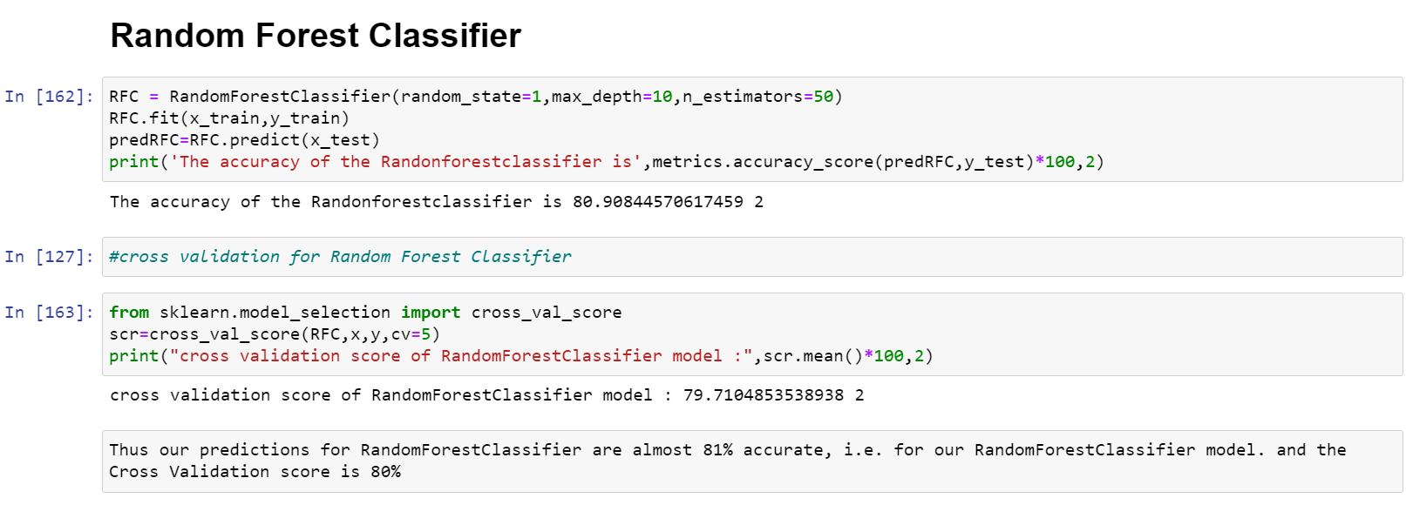

With Random Forest Classifier we got accuracy of 80% and cross validation report gives 80%.

1. **Decision Tree Classifier**

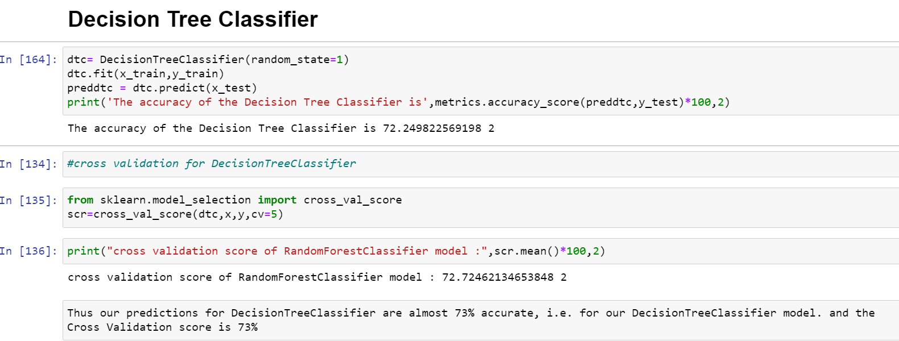

For Decision Tree Classifier, we have used following metrics and accuracy received is 74% and cross validation as 73%

1. **KNeighbors Classifier**

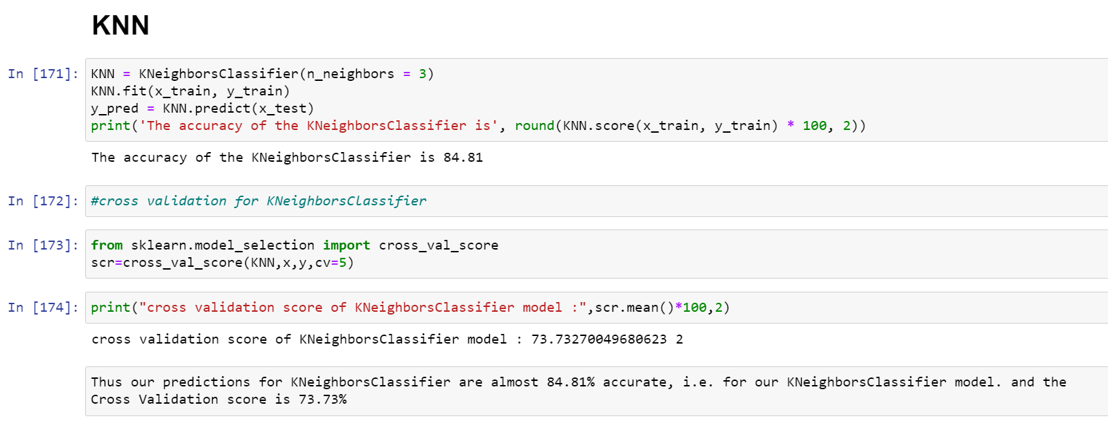

With Kneighbors Classifier, we got accuracy of 83% but the cross-validation score is 67%. Thus, we can see that there is huge difference in accuracy and cross validation thus inspite of highest score it cant be consider as best fit model.

1. **Support Vector Machine**

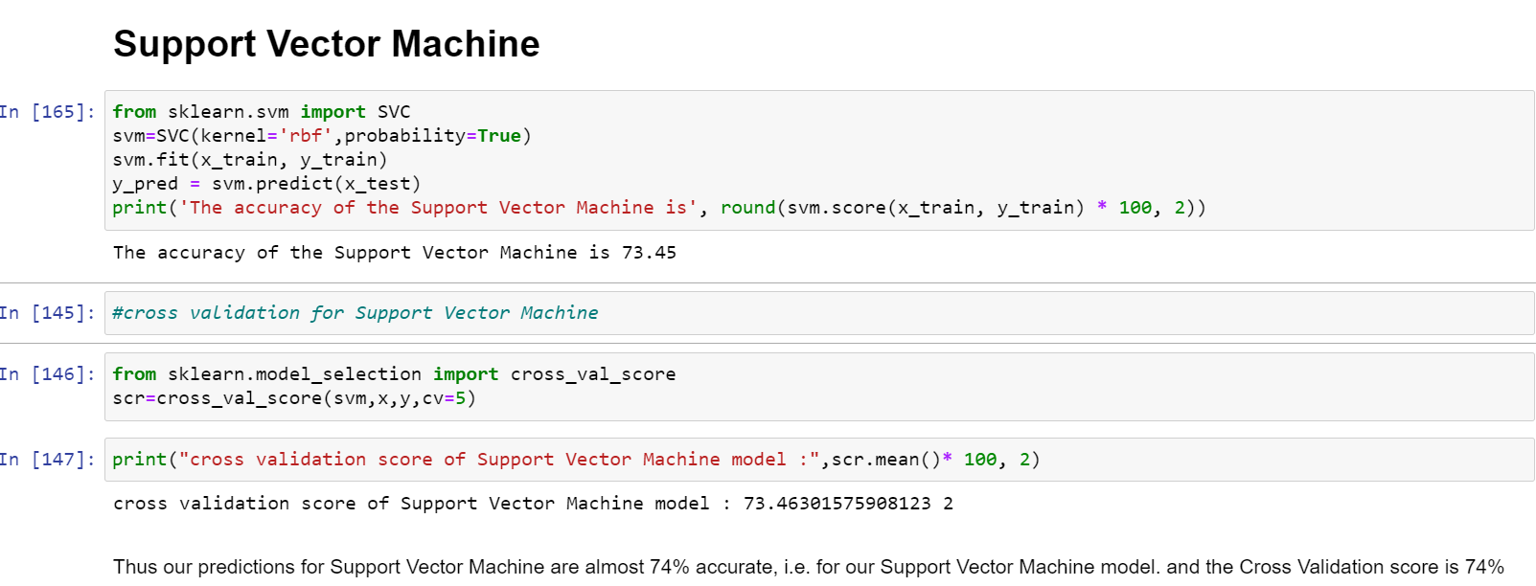

With Support Vector machine, we are getting accuracy of 74% and cross validation as also 74%.

We have used 5 algorithms to predict the customer churn and observed that Logistic Regression and Random Forest Classifier giving the best model for prediction.

Thus, we have taken Logistic Regression as best fit model as it has highest accuracy score; so, we performed hyper parameter tuning on Logistic Regression.

Hyper Parameter Tuning:

To address the potential bias stemming from the specific split of the data in the train-test-split part, cross-validation is used during hyperparameter tuning with Grid Search.

* After identifying the best model as Logistic Regression, we used the GridSeachCV, so we can find the best param and then we used these param for that model as shown in below figure.

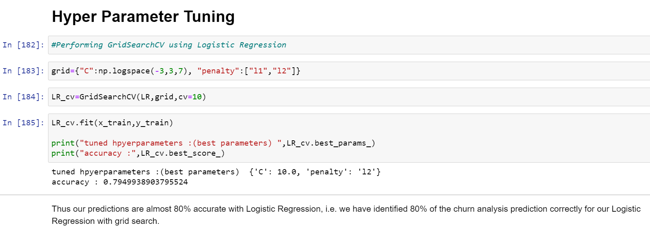

Thus, it proved that the model we have chosen i.e. Logistic Regression is giving highest accuracy of 80% which is very much closer to accuracy got after performing gridsearch CV on that model.

# Conclusion

Thus, we can conclude that by performing all classifier models, we came to know about the best model that predict the customer churn. Looking at model results, the best accuracy on the dataset is achieved by the Logistic Regression.

A high accuracy is needed to be able to identify promising customer cases where churn can be avoided as, eventually, the customer returns protected need to outweigh the costs of related retention campaigns.

Saved the best fit model using library joblib that can be useful to calculate the accuracy score and predict outcomes on new data.

Check out the ‘Customer churn Prediction’ entire code on my Github profile:

<https://github.com/github-pooja/Data-Trained-Practice-Projects/blob/main/Customer%20Churn%20Analysis%20(2).ipynb>

Thank You.